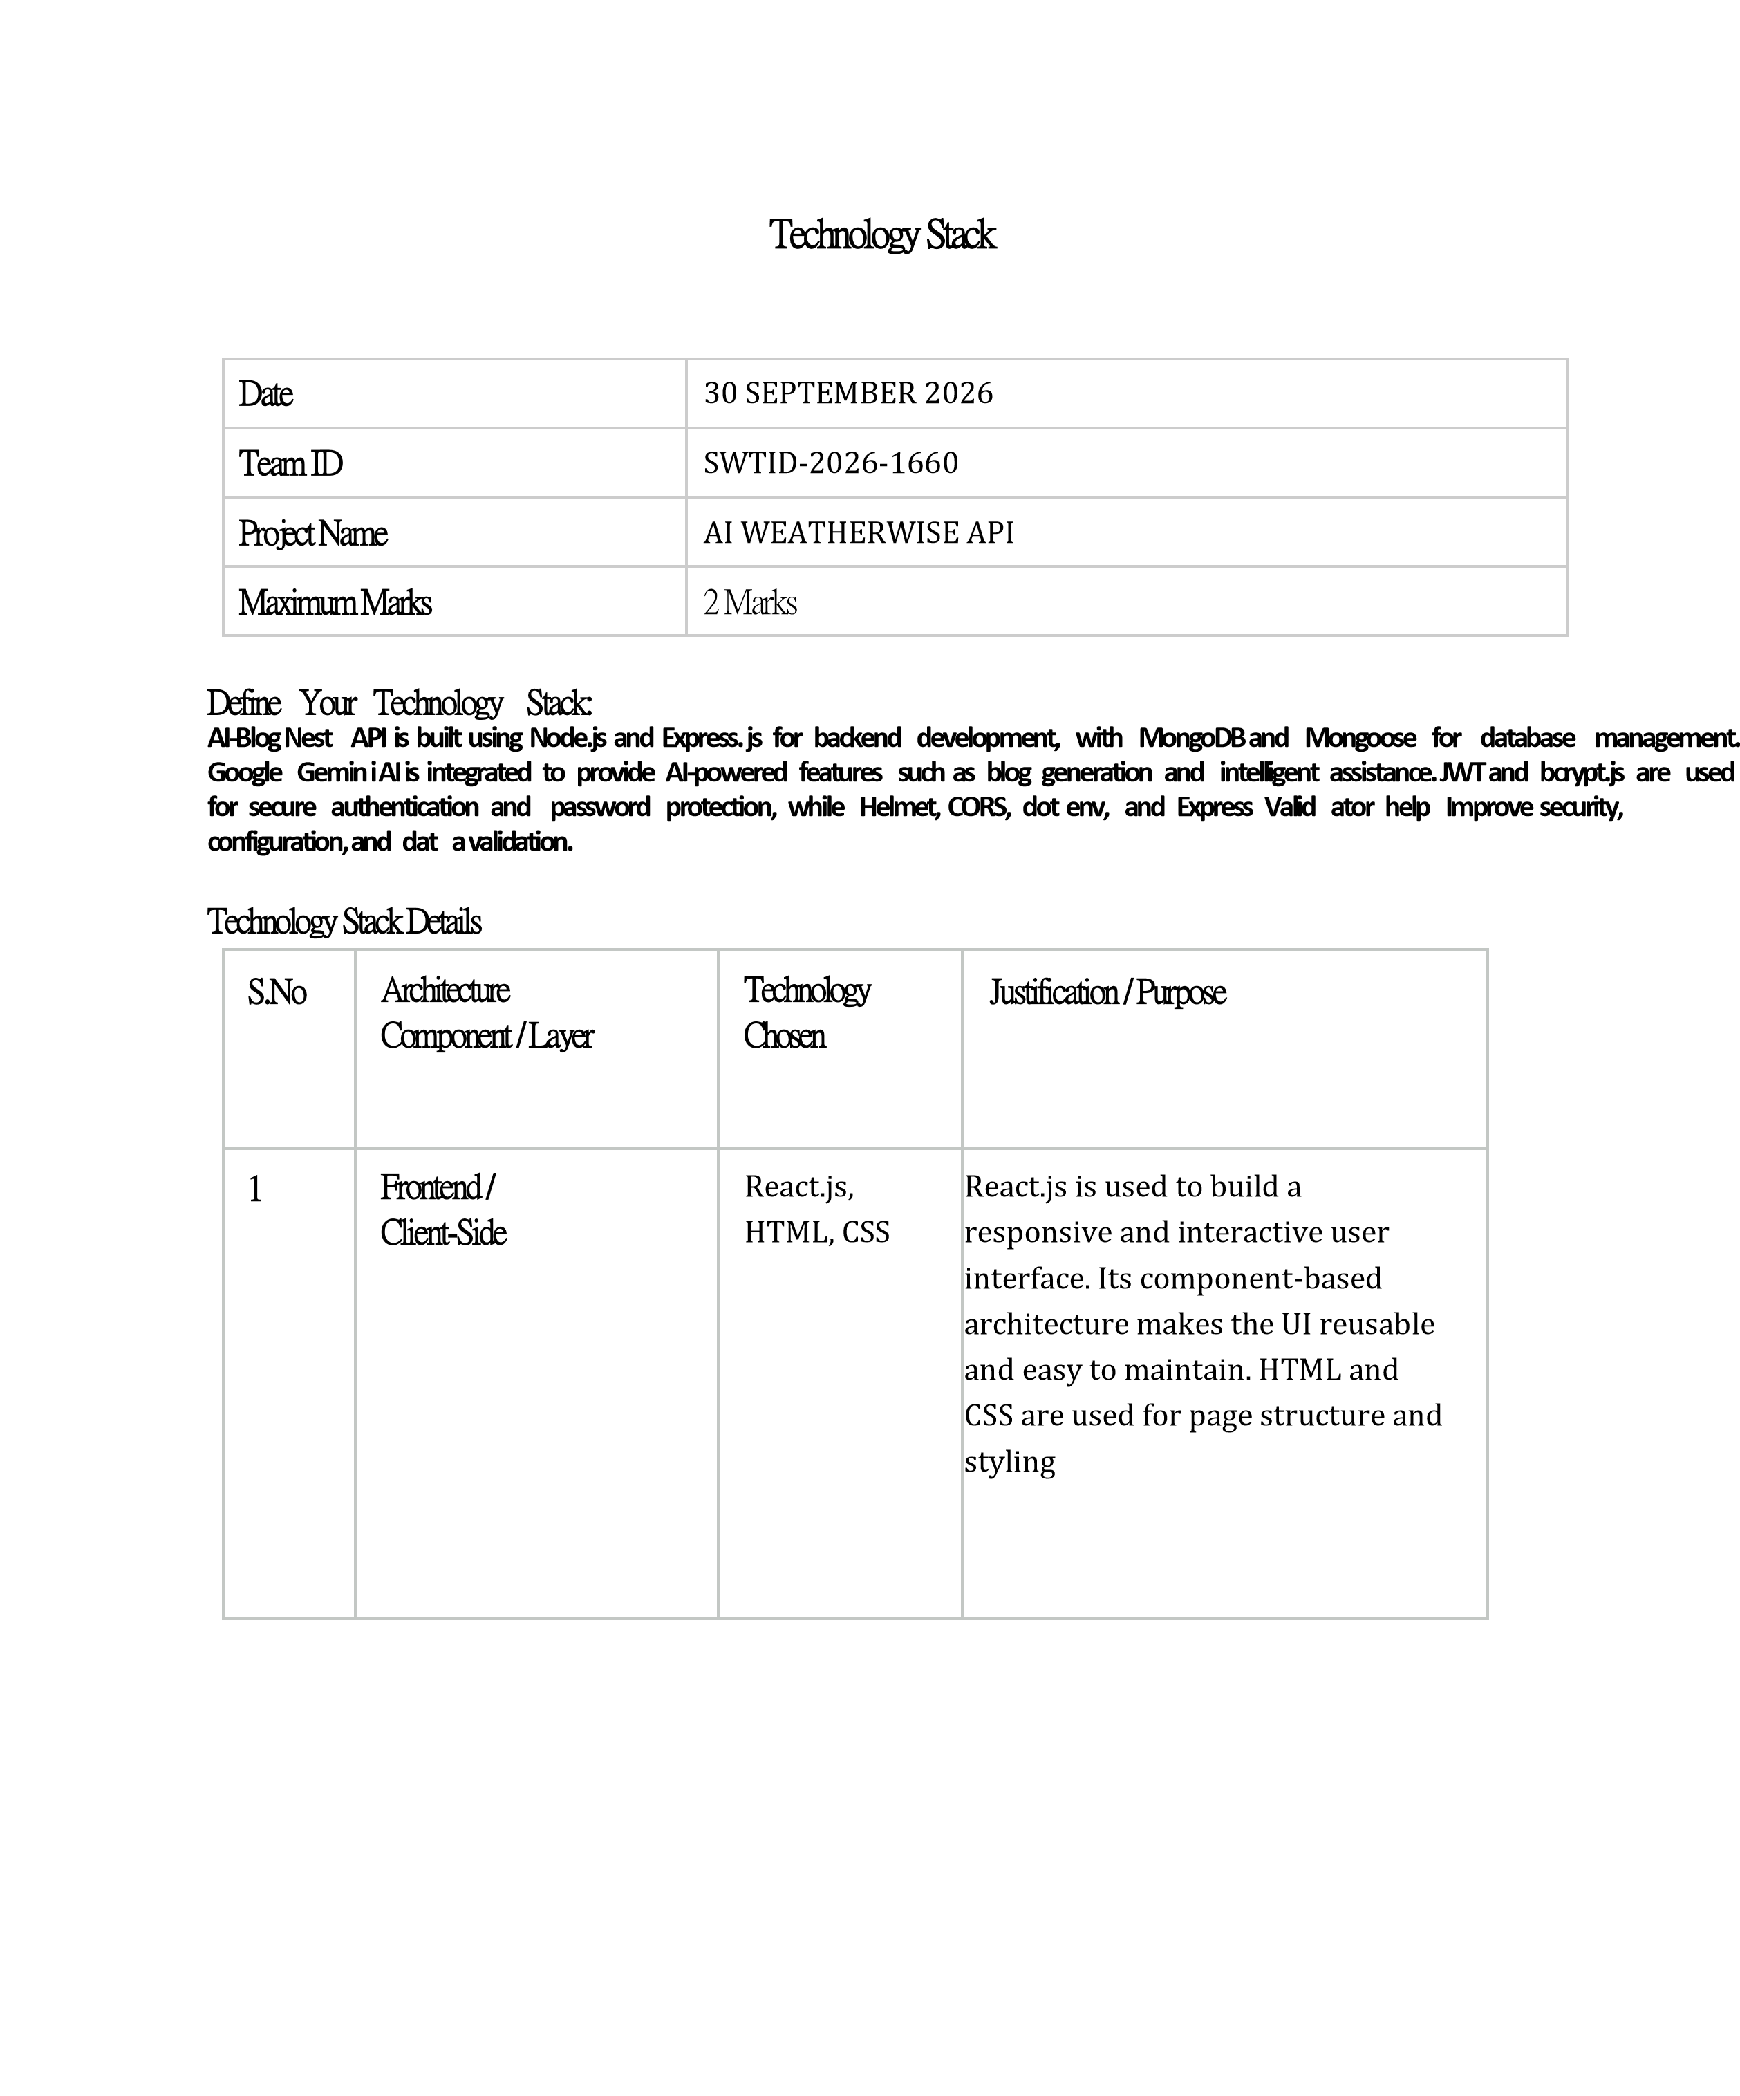

2 | Backend /  Server-Side | Node.js,  Express.js | Node.js provides fast and efficient server-side processing, while Express.js simplifies API development and routing. They are suitable for building scalable RESTful APIs for the AI BlogNest
 |  |  | application.
3 | Database / Data Storage | MongoDB | MongoDB is used to store blog posts, user information, comments, and other application data. Its flexible document-based structure is suitable for handling blog content and allows easy data management.
4 | Cloud / Hosting /  Deployment | Render /  Vercel /  MongoDB  Atlas | Render can be used to deploy the Node.js and Express.js backend API, while Vercel can host the React.js frontend. MongoDB Atlas provides cloud-based database storage, making the application accessible, scalable, and easier to maintain.
5 | Version Control &  CI/CD | Git, GitHub,  GitHub Actions | Git is used to track code changes and maintain different versions of the project. GitHub provides remote code hosting and collaboration. GitHub Actions automates testing, building, and deployment whenever new changes are pushed to the repository.


6

Third
-
Party APIs /

Other Tools

Google
Gemini API,
Postman,
Swagger/Op
enAPI

Google Gemini API provides
AI
-
powered blog generation
and content assistance.
Postman is used to test and
debug REST APIs, while
Swagger/OpenAPI is used to
document and interact with
the API endpoints.

